Software Requirements Specification

Project: Online Ticket Reservation System
Prepared by
S.No | NAME | REGISTRATION NO.
1 | PAREE KHATRI | 23BCY10194
2 | DEEPIKA | 23BCY10185
3 | SHREYA PRAKASH | 23BCY10243
4 | GEETANJALI SINGH | 23BCY10238
5 | DIVYANSHI CHOUHAN | 23BCY10152

Date Created:10th September, 2025

Organization: Vellore Institute Of Technology

Table of Contents
- Introduction
1.1 Purpose
1.2 Document Conventions
1.3 Intended Audience and Reading Suggestions
1.4 Product Scope
1.5 References
- Overall Description
2.1 Product Perspective
2.2 Product Functions
2.3 User Classes and Characteristics
2.4 Operating Environment
2.5 Design and Implementation Constraints
2.6 User Documentation
2.7 Assumptions and Dependencies
- External Interface Requirements
3.1 User Interfaces
3.2 Hardware Interfaces
3.3 Software Interfaces
3.4 Communications Interfaces
- System Features
4.1 Ticket Booking and Cancellation
4.2 Payment Integration
- Other Nonfunctional Requirements
5.1 Performance Requirements
5.2 Safety Requirements
5.3 Security Requirements
5.4 Software Quality Attributes
5.5 Business Rules
- Other Requirements
Appendix A: Glossary
Appendix B: Analysis Models
Appendix C: To Be Determined List

1. Introduction

1.1 Purpose

This document describes the functional and non-functional requirements for the Online Reservation System (ORS). The ORS is a web-based application designed to allow customers to browse available services, check availability, and make reservations online. This SRS covers the core reservation management system, including user accounts, admin management, and payment processing.

Functional Requirements
ID | Requirement | Priority | Description
FR-001 | Search Functionality | High | The system shall allow users to search for businesses by name, location, and service type
FR-002 | Availability Display | High | The system shall display available time slots for a selected service, date, and party size
FR-003 | Double-Booking Prevention | High | The system shall prevent double-booking for the same time slot
FR-004 | User Authentication | High | The system shall require user login/registration before finalizing a reservation
FR-005 | Payment Processing | High | The system shall integrate with payment APIs to securely process payments
FR-006 | User Registration | Medium | The system shall allow new users to register with email and password
FR-007 | User Login | Medium | The system shall allow registered users to log in to their accounts
FR-008 | Profile Management | Medium | The system shall allow users to view and edit their profile information
FR-009 | Reservation History | Medium | The system shall allow users to view their reservation history
FR-010 | Admin Dashboard Access | High | The system shall allow administrators to log in to a secure dashboard
FR-011 | Reservation Management | High | The system shall allow admins to view all upcoming reservations
FR-012 | Availability Management | High | The system shall allow admins to update weekly availability schedules
FR-013 | Special Date Management | Medium | The system shall allow admins to manually add "blocked" dates
FR-014 | Email Notifications | Medium | The system shall send automated email confirmations and reminders
FR-015 | Reservation Modification | Medium | The system shall allow users to modify existing reservations
FR-016 | Reservation Cancellation | Medium | The system shall allow users to cancel reservations
FR-017 | Business Information Display | Low | The system shall display business details (hours, location, menu)

Non-Functional Requirements
ID | Category | Requirement | Description
NFR-001 | Performance | Page Load Time | The system shall load any page in under 2 seconds under normal load
NFR-002 | Performance | Query Response Time | Availability check queries shall return results in less than 1 second
NFR-003 | Performance | Concurrent Users | The system shall support up to 500 concurrent users
NFR-004 | Security | Password Storage | All user passwords shall be hashed using bcrypt before storage
NFR-005 | Security | Payment Data Handling | The system shall not store full credit card numbers or CVV codes
NFR-006 | Security | Session Management | User sessions shall expire after 30 minutes of inactivity
NFR-007 | Security | Vulnerability Scanning | The application shall be scanned for OWASP Top 10 vulnerabilities
NFR-008 | Security | Data Encryption | All sensitive data transmission shall use HTTPS (TLS 1.2+)
NFR-009 | Usability | Task Completion Time | The reservation process shall be completable by a new user in under 5 minutes
NFR-010 | Reliability | System Availability | The system shall aim for 99.5% uptime
NFR-011 | Maintainability | Code Quality | The code shall be well-commented and adhere to style guides
NFR-012 | Compatibility | Browser Support | The system shall support latest versions of Chrome, Firefox, Safari, and Edge
NFR-013 | Compatibility | Mobile Responsiveness | The interface shall be fully functional on mobile devices
NFR-014 | Scalability | Database Performance | The database shall be optimized to handle increasing reservation data
NFR-015 | Operational | Backup System | The database shall be backed up automatically every 24 hours
NFR-016 | Operational | Logging | The system shall log all security-critical events
NFR-017 | Compliance | PCI DSS Compliance | All payment processing must be PCI DSS compliant
NFR-018 | Internationalization | Multi-language Support | The system must support both English and Spanish languages

1.2 Document Conventions
- Headings: Bold
- Requirements: REQ-1, REQ-2 format
- Technical terms explained in the glossary

1.3 Intended Audience and Reading Suggestions

Project Managers & Stakeholders: Focus on Sections 1 (Introduction), 2 (Overall Description), and 4 (System Features)

Developers: Must read the entire document to understand what to build

Testers: Focus on Sections 3 (External Interfaces), 4 (System Features), and 5 (Nonfunctional Requirements)

UI/UX Designers: Focus on Section 3.1 (User Interfaces)

1.4 Product Scope

Customers and businesses rely on inefficient, manual processes for reservations. Customers must call during business hours, often facing busy lines or inaccurate availability information. Businesses struggle to manage reservations across multiple channels (phone, walk-in, third-party apps), leading to double-bookings, lost revenue from no-shows, and an inability to collect valuable customer data for marketing. This results in a frustrating experience for both parties and operational inefficiencies for businesses.

The Online Reservation System (ORS) is a comprehensive web-based platform designed to streamline the end-to-end booking process for service-based businesses, enabling customers to discover availability, make reservations, and manage appointments in real-time, while providing businesses with a centralized tool to manage bookings, reduce manual errors, prevent overbooking, and enhance customer engagement through automated confirmations and reminders.

1.5 References
- Project Charter: "Online Reservation System Project Charter v1.2"
- UI Style Guide: "Company UI/UX Design System v3.0"
- PCI DSS Standard: Payment Card Industry Data Security Standard
Additional System Features to Consider
Feature | Description | Key Functional Requirements
Recommendation Engine | Suggests events, destinations, or services based on user's booking history, search patterns, and demographic data. | FR-301: The system shall analyze user's past bookings to generate personalized recommendations.  FR-302: The system shall allow users to opt-in/opt-out of data collection for recommendations.
Loyalty &Rewas Program | Incentivizes repeat customers with points on each booking, which can be redeemed for discounts, free upgrades, or exclusive access. | FR-303: The system shall assign loyalty points for every completed transaction.  FR-304: The system shall provide a dashboard for users to view and redeem their points.
Multi-Vendor/Partner Onboarding | A backend system for different service providers (e.g., IRCTC, BookMyShow, local bus operators) to integrate their inventory into our platform. | FR-305: The system shall provide a secure API portal for partners to push their inventory and pricing data.  FR-306: The system shall handle reconciliation and settlement with different partners.
Integrated Travel Planner | Allows users to book interconnected itineraries (e.g., Train to Delhi + Movie on arrival + Hotel stay). | FR-307: The system shall allow users to create and book a "travel plan" consisting of multiple reservations.  FR-308: The system shall ensure logical constraints (e.g., event date must be after travel arrival date).
AI-Powered Customer Support Chatbot | Handles common queries like booking status, cancellation policies, and payment issues, reducing load on human support. | FR-309: The chatbot shall be trained on the FAQ and knowledge base to answer common queries.  FR-310: The chatbot shall seamlessly escalate complex issues to a human agent.

2. Overall Description

2.1 Product Perspective

The ORS is a new, self-contained web application. It will integrate with third-party payment gateways (e.g., Stripe) for processing transactions and will send email confirmations via a transactional email service .

2.2 Product Functions

User registration, login, and profile management

Browse services and view business details (hours, location, menu)

Check real-time availability for a selected service, date, and time

Create, view, modify, and cancel reservations

Process secure online payments for reservations requiring pre-payment

Send automated email/SMS confirmations and reminders
- Provide personalized recommendations for events and travel based on user history and preferences.
- Manage a loyalty and rewards program where users earn and redeem points.
- Facilitate onboarding and inventory management for multiple vendors/partners (e.g., IRCTC, event organizers).
- Allow users to create and book integrated travel plans (e.g., train + event + hotel).
- Provide AI-powered customer support through an intelligent chatbox.

Administrative dashboard for business owners

2.3 User Classes and Characteristics

Guest User: A user without an account. Can browse services but must create an account to make a reservation (Low Priority)

Customer (Registered User): A user with a registered account. Can perform all reservation activities and view their history (High Priority)

Business Administrator: An employee of a business. Can update business information, set availability, and view all reservations for their business (High Priority)

System Administrator: Manages the overall application, user accounts, and all business accounts (Medium Priority)

2.4 Operating Environment
- Web Browsers: Chrome, Firefox, Edge
- Front-end: Responsive web app compatible with latest versions of Chrome, Firefox, Safari, and Edge
- Back-end: Server will run on Linux (Ubuntu 20.04 LTS) using a Node.js/Python runtime environment
- Database: A relational SQL database (PostgreSQL 13+)

2.5 Design and Implementation Constraints

The user interface must adhere to the corporate "UI/UX Design System v3.0"

All payment processing must be PCI DSS compliant

Must support both English and Spanish languages (i18n)

2.6 User Documentation

The project will include comprehensive user documentation tailored for different audiences. For end-users, this consists of an in-app help system with tooltips and a public FAQ page. Business administrators will receive a detailed digital manual and context-sensitive help within their dashboard. Technical system administrators will be provided with a technical installation guide and full API documentation. All materials will be written in clear, concise language and adhere to the company's style guide. Documentation will be made available in both English and Spanish to match the application's internationalization support.

2.7 Assumptions and Dependencies
The project's success depends on several key factors. Critical assumptions include stable business requirements and that users have internet access and basic digital literacy. The system also assumes businesses will proactively manage their own availability. Key external dependencies include the Stripe API for payments and the SendGrid API for email notifications. Any changes to these third-party services could impact the project. An internal dependency is the company's IT department providing and maintaining the required server infrastructure. If these assumptions prove false or dependencies change, the project's scope and timeline may be affected.
Key Dependencies:
- Third-Party Services (External Dependencies):
  - Payment Gateway: The project is dependent on the Stripe API for processing secure payments. Any changes to its API, pricing, or terms of service could impact the project.
  - Email Service: The notification system is dependent on the SendGrid API (or a similar transactional email service) for delivering emails reliably. Service outages would directly impact user communication.
  - SMS Service (Future): Implementation of SMS reminders is dependent on the selection and integration of a third-party SMS gateway provider.
- Internal Dependencies:
  - Infrastructure: The project is dependent on the company's IT department to provision and maintain the required staging and production server environments that meet the specified operating environment

3. External Interface Requirements

3.1 User Interfaces
• Registration/Login: A clear process for new users to register and for existing users to log in securely.
• Search Functionality: An efficient search bar to find events, movies, or transportation based on criteria like date, location, and type.
• Booking Flow: A straightforward, step-by-step process for selecting tickets, seats, and completing the reservation.
• Ticket Display: Digital tickets should be easily accessible within the user's account and printable.
• Feedback/Support: A dedicated section for users to provide feedback or access customer support.
• Real-time Updates: The interface should display real-time availability of seats or tickets to prevent overbooking.
• Confirmation: A clear confirmation page and email notification after a successful booking or cancellation.

3.2 Hardware Interfaces
• Server: The system requires a dedicated server with sufficient processing power and storage to handle concurrent user requests.
• Database Server: A separate server or a dedicated partition for the database to ensure high performance and data integrity.
• Payment Terminals: The system must interface with point-of-sale (POS) devices for in-person ticket purchases, if applicable.
• Printers: Support for standard printers to generate physical copies of tickets or receipts.
• Barcode/QR Code Scanners: Compatibility with scanners at entry points to validate digital tickets.
• Networking Hardware: High-speed routers, switches, and firewalls to ensure secure and reliable network communication.
• Backup Systems: Redundant hardware for data backup and disaster recovery.
• Mobile Devices: Compatibility with various smartphones and tablets for accessing the mobile version of the system.

3.3 Software Interfaces
• Payment Gateways: Integration with third-party payment gateways like PayPal, Stripe, or local banking APIs to process transactions securely.
• Email Services: An API for an email service (e.g., SendGrid, Mailchimp) to send booking confirmations, updates, and promotional emails.
• SMS Services: An interface with an SMS gateway to send instant notifications and ticket links.
• Operating System: The system must be compatible with standard operating systems like Linux, Windows Server, or macOS.
• Web Server: An application server like Apache or Nginx to host the website and handle HTTP requests.
• Database Management System: Compatibility with a robust DBMS like MySQL, PostgreSQL, or MongoDB for data storage.
• Third-Party APIs: Integration with APIs for maps (e.g., Google Maps) for location services or event data providers.
• Reporting Tools: An interface for business intelligence or reporting software to analyze sales data and user behavior.

3.4 Communications Interfaces
- HTTPS Protocol: All data transmission, especially payment information, must be secured using the HTTPS protocol.
- RESTful APIs: Use of RESTful APIs for communication between the front-end and back-end, ensuring a stateless and scalable architecture.
- SSL/TLS Encryption: Implementation of SSL/TLS certificates to encrypt all data exchanged between the user's browser and the server.
- Secure Socket Layer: Use of SSL for all database and API connections to prevent data interception.
- Authentication Tokens: Use of tokens (e.g., JWT) for secure user authentication and session management.
- Firewall Configuration: Proper firewall rules to allow traffic only on specific ports and block unauthorized access.
- Push Notifications: Use of communication protocols for sending push notifications to mobile devices.
- WebSockets: Potential use of WebSockets for real-time seat availability updates and chat functionality.

4. System Features

This section describes the core functionalities of the online ticket reservation system.

4.1 Ticket Booking and Cancellation
• Search and Filter: Users can search for tickets based on various parameters (event, date, location, price range).
• Real-time Availability: The system must display the real-time availability of seats or tickets to prevent double-booking.
• Seat Selection: For events with assigned seating, users should be able to select their preferred seats from an interactive map.
• Shopping Cart: A temporary cart to hold selected tickets before the final payment.
• Booking Confirmation: After a successful transaction, the system will generate a unique e-ticket with a QR code or barcode.
• Cancellation Policy: The system must enforce a predefined cancellation policy, including refund rules and deadlines.
• Cancellation Process: A straightforward process for users to initiate a ticket cancellation request through their account.
• Refund Processing: The system should automatically process refunds to the original payment method based on the cancellation policy.

4.1.1 Description and Priority:
The following points detail the requirements for the Ticket Booking and Cancellation feature, which has a High Priority due to its central role in the system. The stimulus/response sequence for this feature is a core user flow.
- Search Functionality: The system must allow users to search for trains based on origin, destination, and travel date. The search results should display available trains, including departure/arrival times, travel duration, and fare classes.
- Real-time Availability: The system must show real-time seat availability for different classes (e.g., First Class, Sleeper, General). As users book tickets, the system should update the available count instantly to prevent overbooking.
- Booking Process: Users must be able to select their desired train and seats. The booking process should include a secure payment gateway and should be completed with a minimal number of steps to ensure a smooth user experience.
- Payment Confirmation: Upon successful payment, the system must generate a digital ticket and send a booking confirmation to the user via both email and SMS. The confirmation should include all journey details, the referral number, and a link to the digital ticket.
- Cancellation Policy: The system must enforce a clear and automated cancellation policy. Users should be able to cancel their tickets through the system, and the refund amount should be calculated based on the systems rules (e.g., cancellation fees, time-based refunds).
- Cancellation Confirmation: Similar to booking, the system must send an immediate confirmation of the cancellation to the user via email and SMS. This message should include the amount refunded and the Referal number for reference.
- Referal Status Check: The system must provide a feature for users to check their referral status, including details about their booking and current reservation status, even without logging in. This enhances transparency and user trust.

4.1.2 Stimulus/Response Sequences:
Stimulus/response sequences define the interaction between the user and the system. They describe what the system does in response to a specific action from the user. Here are 7-8 points on this topic:
- User Action (Stimulus): The sequence begins with an action initiated by the user. This can be anything from clicking a button, entering text, or selecting an item from a list.
- System Acknowledgment: The system should provide immediate feedback to the user's action. For instance, a button might change color, a loader might appear, or a message might confirm that the system is processing the request.
- Data Validation: Before proceeding, the system validates the input. If a user enters an invalid email address in a registration form, the system will respond with an error message, telling the user to correct the input.
- System Processing: The system processes the user's request. This can involve querying a database for information, performing a calculation, or communicating with another service. This is often an internal step not directly visible to the user.
- System Response: After processing, the system provides a clear and predictable response. This could be a new page, a pop-up window, a list of search results, or a confirmation message. For example, a successful booking request should lead to a confirmation page.
- Error Handling: If an error occurs during processing (e.g., a payment failure or an internal server error), the system must handle it gracefully. It should provide a clear and actionable error message to the user, suggesting a solution or a way to contact support.
- State Change: A successful response often results in a change to the system's state. After a user books a ticket, the number of available seats is updated in the database, and the ticket is marked as reserved.
- Confirmation Loop: The sequence often ends with a final confirmation that the action was completed. This might be a confirmation email, an SMS notification, or a transaction receipt, providing the user with a permanent record of their action.

4.1.3 Functional Requirements:
Functional requirements define the specific functions the system must perform. Here are 7-8 key functional requirements for an Online Ticket Reservation System:
- User Registration and Profile Management: The system must allow new users to register with a valid email and password. It should also enable existing users to log in, update their personal information, and change their password.
- Ticket Search and Filtering: The system must provide a search function that allows users to find tickets based on specific criteria such as event name, date, location, and price range. It should also support filtering of search results.
- Real-time Availability Display: The system must accurately show the number of available tickets or seats in real-time. This prevents overbooking and ensures users see the most current information.
- Secure Ticket Booking: The system must facilitate the secure selection of tickets and seats. It must then guide the user through the booking process, ensuring that the selected tickets are held for a limited time to prevent other users from booking them simultaneously.
- Payment Processing: The system must integrate with secure payment gateways to process transactions using various methods like credit cards, debit cards, and digital wallets. It should confirm a successful transaction and provide an electronic receipt.
- Ticket Confirmation and Delivery: Upon successful payment, the system must generate a unique digital ticket with a scannable QR code or barcode. It should then send a confirmation email containing the ticket details and a link to view or download the ticket.
- Ticket Cancellation and Refund: The system must allow users to cancel their tickets according to the predefined cancellation policy. It should automatically process the refund to the user's original payment method, deducting any applicable cancellation fees.
- Event and Ticket Management (Admin): An administrative interface must be available for system administrators to add, modify, or delete events, manage ticket types, adjust pricing, and view booking reports. This allows for effective system oversight.

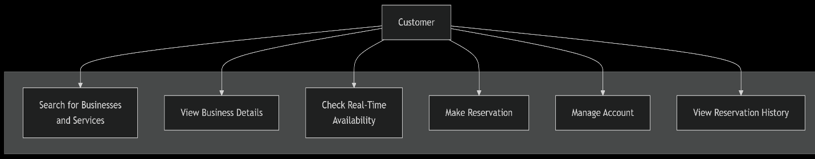
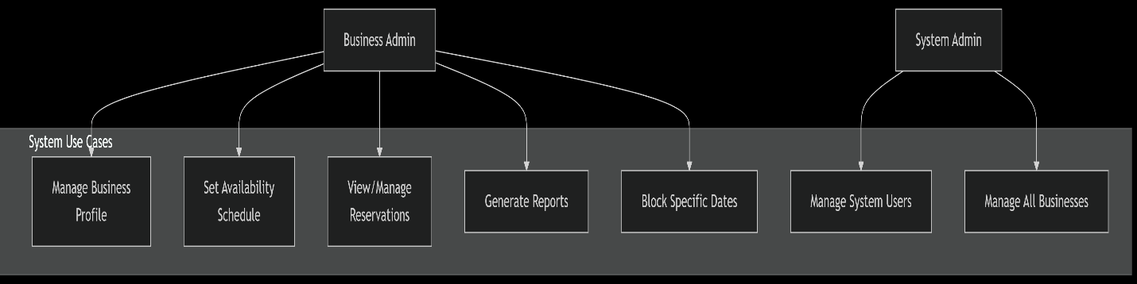

4.2 Payment Integration
• Multiple Payment Methods: The system should support various payment options, including credit/debit cards, net banking, and digital wallets.
• Secure Transactions: All payment transactions must be processed through a PCI DSS compliant payment gateway.
• Transaction Status: The system must provide real-time updates on the status of a payment (e.g., success, failure, pending).
• Transaction History: Users should be able to view their complete payment history within their profile.
• Fraud Detection: The system should integrate with fraud detection services to identify and prevent fraudulent transactions.
• Receipt Generation: An automated process for generating and sending a digital receipt for every successful payment.
• Currency Conversion: The system should support multiple currencies, with automatic conversion rates if needed.
• Tokenization: Implementation of payment tokenization to securely store card information for future transactions without saving the actual card number.

4.2.1 Description and Priority:
Securely handle payment using third-party API. Priority: High
The system must securely handle all payment transactions by integrating with a third-party payment gateway API such as Stripe, PayPal, or a local banking service. This feature is crucial for processing payments for ticket bookings. The system will not store sensitive financial information like credit card numbers directly. Instead, it will use tokenization to create a secure token that represents the user's card details. This token is then sent to the payment gateway to process the transaction. The third-party API will handle the entire transaction, including validation and fraud checks, and will send back a transaction status (e.g., success, failure).

Priority: High
This feature is assigned a high priority because:
- Core Functionality: Without a functional and secure payment system, the primary goal of the ticket reservation system—selling tickets—cannot be achieved.
- Security and Trust: Handling financial transactions securely is non-negotiable. Any security vulnerabilities could lead to data breaches, financial loss for users, and severe damage to the system's reputation.
- Legal and Compliance: To accept online payments, the system must comply with standards like PCI DSS (Payment Card Industry Data Security Standard). Using a third-party, compliant API is the most effective and secure way to meet these requirements.
- User Experience: A smooth, reliable, and secure payment process is critical for a positive user experience. A failed or insecure payment can lead to user frustration and abandonment of the booking.

4.2.2 Stimulus/Response Sequences:
User proceeds to payment → Gateway interaction → Payment result returned

4.2.2 Stimulus/Response Sequences:
Here is a breakdown of the stimulus/response sequences for the payment process.
- Stimulus: User Initiates Payment
  - User Action: The user clicks the "Pay Now" or similar button after selecting their tickets. This action sends a request to the system's back-end.
- Response: System Prepares for Gateway Interaction
  - System Response: The system validates the user's order details and generates a unique transaction ID. It then sends a request to the payment gateway's API, including the transaction amount, currency, and other necessary details. The system's front-end will display a loading or processing message to the user.
- Stimulus/Response: Gateway Interaction
  - Gateway Action: The user is securely redirected to the payment gateway's page or a secure modal, where they enter their payment information (e.g., credit card details). The gateway handles all communication with the user's bank to authorize and capture the payment.
  - Gateway Response: The payment gateway returns a callback or response to the system's back-end. This response contains the final status of the transaction (success, failure, or pending). This is a critical step, as it determines the next action.
- Response: System Processes Payment Result
  - System Action (Success): If the payment is successful, the system confirms the ticket booking, marks the tickets as "paid" in the database, and sends a confirmation email with the digital ticket to the user. The front-end is redirected to a "Booking Successful" page.
  - System Action (Failure): If the payment fails (e.g., due to insufficient funds or a declined card), the system logs the failure and redirects the user to a "Payment Failed" page. This page provides a clear message explaining the issue and an option to retry the payment. No tickets are booked or marked as paid.

4.2.3 Functional Requirements:
The following are the key functional requirements for the payment integration feature:
- Payment Gateway Integration: The system must integrate with at least one secure, third-party payment gateway (e.g., Stripe, PayPal, or a local banking API) to process online payments. 💳
- Support for Multiple Payment Methods: The system must accept a variety of payment methods, including major credit and debit cards (Visa, Mastercard, Amex) and, if applicable, digital wallets (Apple Pay, Google Pay) and net banking.
- Secure Transaction Processing: The system must ensure all payment transactions are handled securely using SSL/TLS encryption. It should not store any sensitive financial data, such as full credit card numbers, on its servers.
- Real-time Transaction Status: The system must be able to receive and interpret real-time transaction status notifications from the payment gateway (e.g., "success," "failure," "pending").
- Automated Confirmation/Failure Handling: Upon receiving a transaction result, the system must automatically update the booking status. A successful payment should lead to a confirmed booking, while a failed payment should not.
- Receipt Generation: The system must automatically generate and send a digital receipt to the user's email address upon successful payment. The receipt should include all transaction details.
- Refund Processing: The system must have the functionality to initiate a refund through the payment gateway API for canceled or failed transactions, adhering to the defined refund policy.
- Payment History: Users must be able to view their complete payment history and transaction details within their user profile on the system.

4.3 Manage User Account
• User Registration: The system must allow users to create an account by providing a valid email address and a strong password. Email verification is mandatory.
• Secure Authentication: The system must provide a secure login process that authenticates users based on their email and password. Password hashes must be stored, not plain text passwords.
• Password Management: The system must offer a "Forgot Password" functionality that securely resets a user's password via an email link. Users should also be able to change their password from their account settings.
• Profile Editing: Users must be able to update their personal information, such as name, phone number, and address, from a dedicated profile management section.
• Booking History: The system must display a detailed list of all past and upcoming bookings for the logged-in user. Each booking record should include details such as event name, date, number of tickets, and transaction status.
• Communication Preferences: Users should be able to manage their communication preferences, such as opting in or out of marketing emails or promotional notifications.
• Account Deactivation: The system should provide an option for users to request account deactivation. The system must inform the user about the consequences of this action and confirm the deactivation.

4.4 Administrative Dashboard
• Secure Authentication: The dashboard must have a separate, secure login for administrators. It must support multiple administrator roles with different access levels (e.g., an event manager and a full system administrator).
• Event Management: The system must allow administrators to create, edit, and delete events. This includes adding event details, uploading images, setting dates and times, and managing ticket inventory.
• User Management: The dashboard must enable administrators to view and manage user accounts. This includes the ability to search for users, update their information, and suspend or delete accounts if necessary.
• Booking and Transaction Management: Administrators must be able to view all bookings and transactions. They should have the ability to search by user, event, or transaction ID, and process manual refunds or cancellations if needed.
• Analytics and Reporting: The system must provide real-time analytics and customizable reports on sales, user activity, and event performance. The data should be exportable in common formats.
• Content Management: An integrated content management system (CMS) should allow administrators to update dynamic content on the website, such as promotional banners, news articles, and FAQs.
• Audit Trail: The system must maintain an audit trail of all administrative actions, recording which administrator performed what action and when, to ensure accountability.

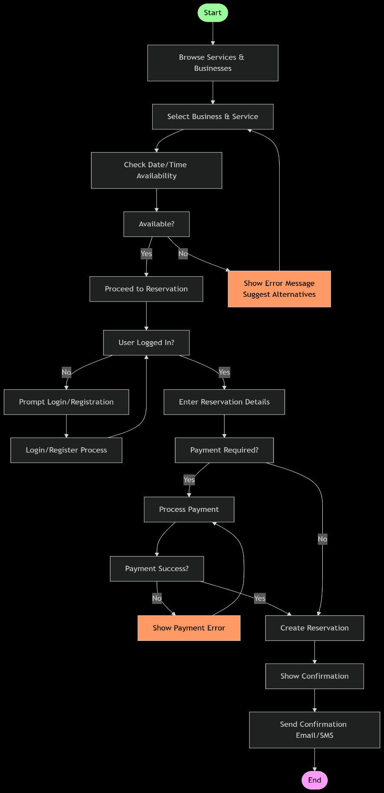

5. Other Nonfunctional Requirements

5.1 Performance Requirements
•Response Time: The system must respond to user requests (e.g., loading a page, confirming a booking) within 2-3 seconds, even during peak usage times.
•Concurrent Users: The system should handle at least 500 concurrent users without a significant degradation in performance.
•Transaction Speed: The booking and payment processing must be completed in under 5 seconds from the time a user clicks "confirm."
•Scalability: The system should be able to scale efficiently to accommodate a 200% increase in user traffic and transactions during a high-demand event.
•Data Load: The database should handle a daily data load of 10,000 new transactions and maintain a consistent query performance.
•System Uptime: The system must maintain an uptime of at least 99.9%, excluding planned maintenance periods.

5.2 Safety Requirements
•Data Integrity: The system must ensure that all reservation data is accurate and not corrupted during transactions, preventing double-bookings or lost reservations.
•Power Outage Protection: The system should be able to recover gracefully from a power outage or server failure without data loss, with any ongoing transactions being rolled back to their pre-outage state.
•Fault Tolerance: The system must have built-in redundancy to handle hardware or software failures in critical components (e.g., payment gateway, database server) without causing a full system crash.
•Backup and Recovery: Regular backups of the entire database must be performed, with a clear recovery plan in place to restore the system to a recent state within 4 hours of a major failure.
•Session Timeout: To prevent unauthorized access, user sessions should automatically expire after a period of inactivity (e.g., 15 minutes).
•Audit Trails: The system must log all critical actions, such as booking modifications or cancellations, to provide an audit trail for accountability and troubleshooting.

5.3 Security Requirements
•Authentication and Authorization: The system must use secure user authentication (e.g., password hashing, MFA) and role-based authorization to restrict access to sensitive features and data.
•Data Encryption: All sensitive user data, including personal information and payment details, must be encrypted both in transit (using HTTPS/SSL) and at rest.
•SQL Injection Prevention: The system's code must be hardened against common web vulnerabilities like SQL injection and cross-site scripting (XSS).
•Secure Payment Gateway: The system must integrate with a PCI DSS-compliant payment gateway to ensure secure handling of credit card information.
•Password Policies: User passwords must meet strong complexity requirements (e.g., minimum length, use of special characters, no common words).
•Access Control: Only authorized personnel (e.g., administrators) should have access to the backend system and database, with their access logged and monitored.

5.4 Software Quality Attributes
•Usability: The system's user interface must be intuitive and easy to navigate, allowing users to complete a booking with a minimal number of steps.
•Maintainability: The codebase should be well-documented, modular, and easy to modify for future updates and bug fixes.
•Portability: The system should be designed to run on a variety of operating systems and web servers, and the front end should be compatible with all major modern web browsers.
•Reliability: The system must consistently perform its functions correctly under specified conditions over a given period, with a low probability of failure.
•Flexibility: The system should be flexible enough to accommodate different types of events or services and allow for the easy addition of new features like loyalty programs or promotional codes.
•Testability: The system must be designed in a way that allows for easy and thorough testing of all its components, both individually and as a whole.

5.5 Business Rules
•Cancellation Policy: A booking can be canceled up to 24 hours before the event, after which no refund will be issued.
•Seat Allocation: Seats are allocated on a first-come, first-served basis, and a seat is considered "held" for a user for 10 minutes after they select it.
•Maximum Bookings: A single user is limited to a maximum of 10 tickets per transaction to prevent scalping.
•Promotional Codes: Promotional codes can only be used once per customer and cannot be combined with other offers.
•Refund Processing: All approved refunds must be processed and credited back to the customer's account within 5-7 business days.•User Accounts: Users must create an account and be logged in to make a booking, though they can browse available tickets as a guest.

6. Other Requirements
- UTF-8 data storage
- GDPR and Indian data protection compliance
- System logs all transactions for audit

Appendix A: Glossary
User: An individual who interacts with the system, including customers, administrators, and event organizers.
•Ticket: A digital or physical proof of purchase for an event, travel, or service.
•Booking: The process of reserving a ticket or seat through the system.
•Payment Gateway: A third-party service that processes and authorizes credit card or other online payments.
•Seat Map: A graphical representation of the seating arrangement for a venue, allowing users to select specific seats.
•Concurrent Users: The number of users simultaneously active on the system at a given moment.

Appendix B: Analysis Models
- Use Case Diagram
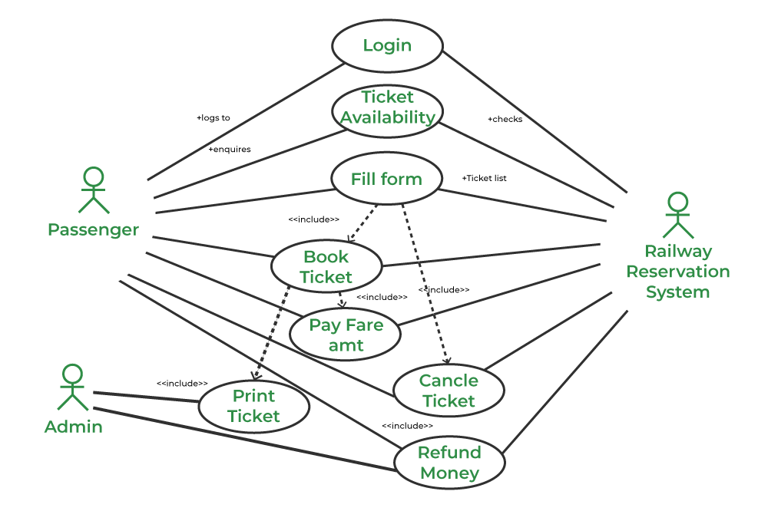

A Use Case Diagram shows the high-level functionality of the system and the roles of the users interacting with it. In this diagram, actors (users) are represented by stick figures, and use cases (the system's functions) are represented by ovals.
- Customer: An actor who wants to book a ticket.
- Administrator: An actor who manages the system's backend.
- Payment Gateway: A third-party service that handles transactions.
The diagram illustrates key use cases such as:
- Browse Events: A customer can view available events without logging in.
- Search for Tickets: A customer can search for events by date, location, or type.
- Book a Ticket: The primary function where a customer selects and reserves a ticket.
- Make Payment: The system interacts with the payment gateway to process the transaction.
- Cancel Reservation: A customer can cancel a booking, subject to business rules.
- Manage Events: An administrator can add, edit, or delete event information.
- View Reports: An administrator can generate reports on sales and bookings.

- DFD (Data Flow Diagram)
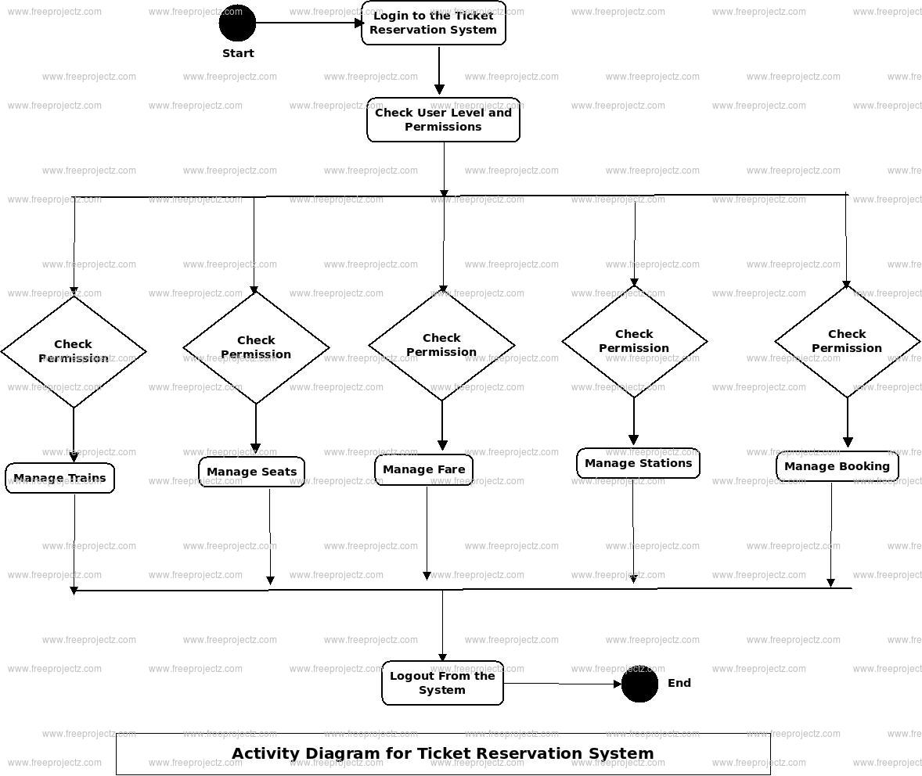

An Activity Diagram models the workflow or flow of control for a specific process, such as the ticket booking process.It uses a series of actions and decisions to show the sequence of steps.
The diagram for booking a ticket would typically show the following flow:
- Start (initial node)
- The user searches for an event.
- The system displays available events.
- The user selects a specific event.
- A decision node checks for seat availability.
  - If seats are available, the user proceeds to select seats.
  - If seats are not available, the user is prompted to choose another event or is redirected back to the search page.
- The user enters personal details and proceeds to payment.
- The system processes the payment.
- A final decision node checks for payment success.
  - If successful, the system generates a ticket and sends a confirmation. The process ends.
  - If unsuccessful, the system shows an error message and prompts the user to retry payment. The process may loop back to a previous step.
- End (final node)

- ER Diagram for ticket, user, and payment entities

- 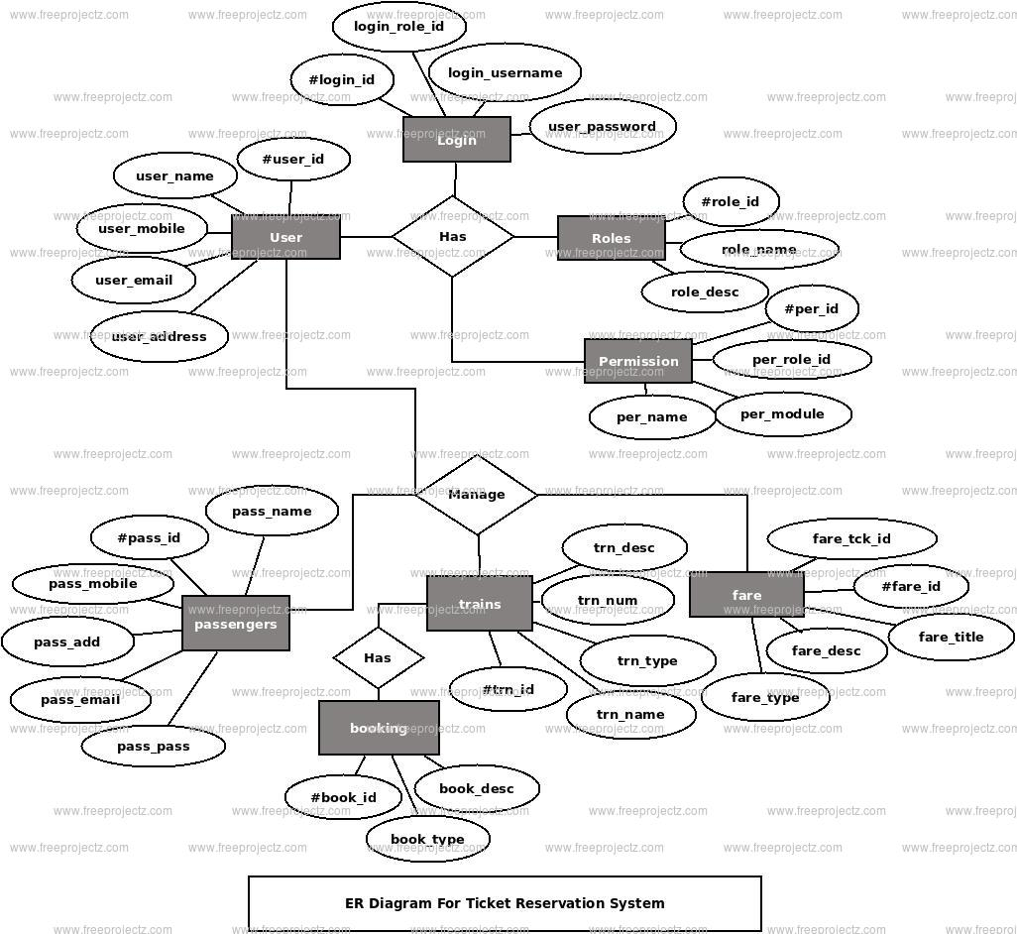

Entities and their Attributes
- Customer: Represents the users of the system.
  - CustomerID (Primary Key): A unique identifier for each customer.
  - FirstName
  - LastName
  - Email
  - Password (stored securely, e.g., hashed)
  - PhoneNumber
  - RegistrationDate
- Event: Represents a specific event, show, or service.
  - EventID (Primary Key): A unique identifier for the event.
  - EventName
  - EventDescription
  - EventDate
  - EventTime
  - VenueID (Foreign Key): Links the event to a specific venue.
  - Status (e.g., "Active," "Sold Out," "Cancelled")
- Venue: Represents the location where an event is held.
  - VenueID (Primary Key): A unique identifier for the venue.
  - VenueName
  - Address
  - City
  - State
  - Capacity
- Ticket: Represents an individual ticket available for an event.
  - TicketID (Primary Key): A unique identifier for each ticket.
  - EventID (Foreign Key): Links the ticket to a specific event.
  - SeatNumber (Can be a composite attribute with Row and Number)
  - Price
  - Status (e.g., "Available," "Reserved," "Sold")
- Booking: A record of a customer's reservation. This is a weak entity dependent on the Customer and Ticket entities.
  - BookingID (Primary Key): A unique identifier for each booking.
  - CustomerID (Foreign Key): Links the booking to the customer who made it.
  - BookingDate
  - TotalAmount
  - PaymentStatus (e.g., "Pending," "Paid," "Failed")
- Payment: Records details of a financial transaction.
  - PaymentID (Primary Key): A unique identifier for the payment.
  - BookingID (Foreign Key): Links the payment to a specific booking.
  - TransactionID (provided by the payment gateway)
  - PaymentMethod (e.g., "Credit Card," "PayPal")
  - PaymentDate
  - Amount

Relationships and Cardinality
- Customer and Booking:
  - Relationship: makes
  - Cardinality: One-to-Many (1:N). A customer can make many bookings, but each booking is made by only one customer.
- Booking and Ticket:
  - Relationship: contains
  - Cardinality: One-to-Many (1:N). One booking can contain multiple tickets, but each ticket belongs to only one booking.
- Event and Ticket:
  - Relationship: has
  - Cardinality: One-to-Many (1:N). An event has many tickets, but each ticket belongs to only one event.
- Event and Venue:
  - Relationship: is_held_at
  - Cardinality: One-to-Many (1:N). An event is held at only one venue, but a venue can host many events over time.
- Booking and Payment:
  - Relationship: is_paid_by
  - Cardinality: One-to-One (1:1). Each booking is associated with a single payment transaction

Sequence Diagram for the "Book Ticket" Use Case
While your activity diagram shows the overall flow, a sequence diagram zoom in on the interactions between objects over time for a specific scenario.
Purpose: To show how system components and actors interact in a time sequence for the successful booking of a ticket.
Description for SRS:
This sequence diagram details the interactions between the user and the various system components during a successful ticket booking process. It highlights the flow of messages and the order of operations, which is crucial for understanding the integration points between the user interface, application logic, database, and external payment gateway.
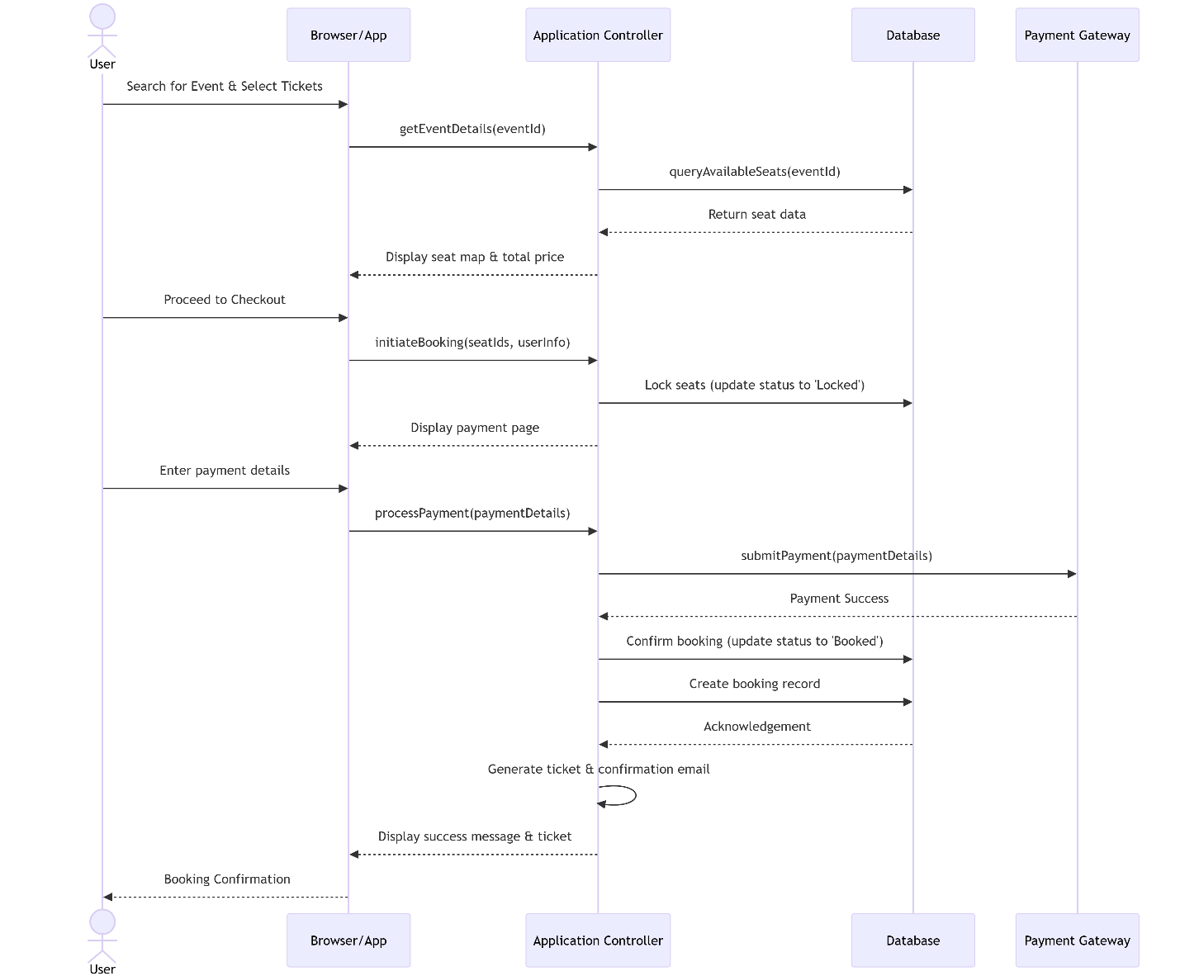
Deployment Diagram
This diagram shows how the system will be physically deployed on hardware infrastructure. It's essential for DevOps and system administrators.
Purpose: To model the physical deployment of artifacts on nodes (hardware).
Description for SRS:
This deployment diagram illustrates the hardware and software execution environment for the system. It specifies how the various software components are deployed on production servers, including web servers, application servers, database servers, and how they interact with external services. This model is crucial for planning infrastructure requirements, understanding network topology, and ensuring performance and reliability.
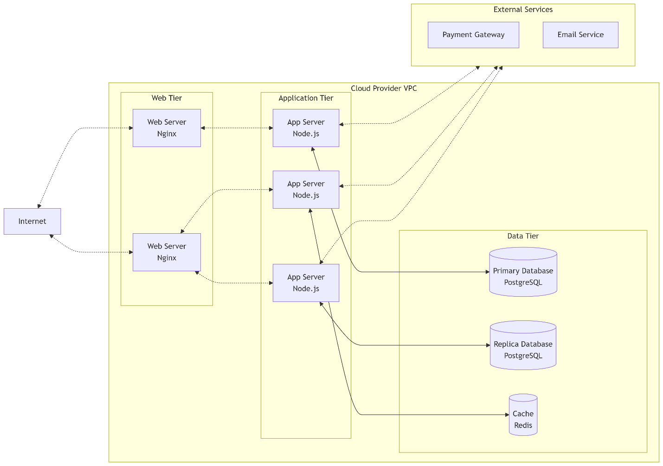

Component Diagram
This diagram shows how the system is broken down into physical or logical components and their dependencies. It's a high-level view of the system architecture.
Purpose: To visualize the structural relationships and dependencies between the software components.
Description for SRS:
The component diagram outlines the high-level architecture of the Online Ticket Reservation System. It demonstrates how the system is decomposed into modular components, each with a well-defined interface. This modularity promotes scalability, maintainability, and ease of deployment, as components like the Payment Service or Notification Service can be developed and scaled independently.

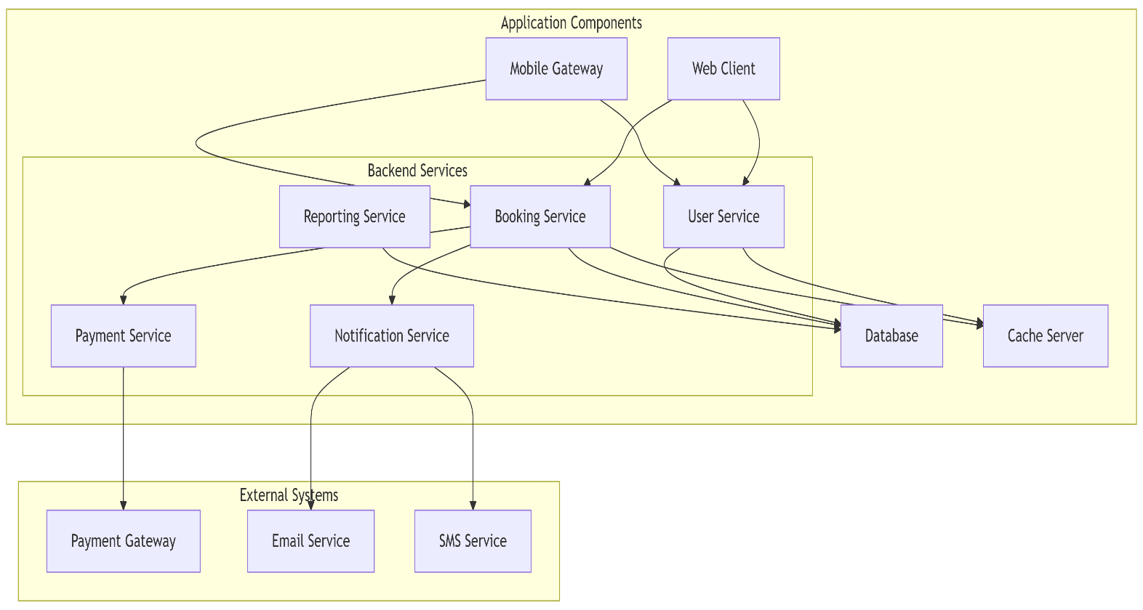

Appendix C: To Be Determined (TBD) List

🎨TBD-1: Final Color Scheme and UI Theme 🎨
The final color scheme and UI theme are TBD because they are essential for brand identity and user experience.
- Brand Consistency: The chosen colors must align with the overall brand identity of the online ticket system, ensuring it is recognizable and professional.
- User Experience (UX): A good color scheme improves usability by creating visual hierarchy, highlighting important actions (like "Buy Now" buttons), and providing a pleasant aesthetic.
- Accessibility: The colors must meet accessibility standards (e.g., WCAG) for sufficient contrast, ensuring that users with visual impairments can easily read text and interact with the interface.
- Emotional Impact: Different colors evoke different emotions. For example, blue can suggest trust and reliability, which is important for a financial transaction system.
- Scalability: The theme should be built on a system that allows for easy changes across the entire application, preventing a need for manual updates on every page. This is important for future updates and A/B testing.

TBD-2: Mobile App Development Decision 📱
The decision to develop a dedicated mobile app is TBD because it's a significant investment that requires careful consideration.
- Target Audience: We need to analyze whether our target users prefer to book tickets on a mobile app versus a mobile-optimized website. If the majority of traffic is from mobile browsers, an app might be a good idea.
- Budget and Resources: Developing and maintaining a mobile app for both iOS and Android requires a separate budget and a dedicated development team, which might not be a priority in the initial project phases.
- Feature Parity: We must decide if the mobile app will have all the same features as the website, or if it will be a streamlined version.
- Platform Strategy: The choice is between building native apps (iOS and Android), which offer the best performance but are more expensive, or a cross-platform solution (e.g., React Native, Flutter), which is more cost-effective but may have performance limitations.
- Maintenance: A mobile app requires ongoing updates to remain compatible with new operating systems, bug fixes, and security patches.
- Offline Functionality: A key benefit of a mobile app is the ability to provide offline features, such as viewing a downloaded ticket without an internet connection. This needs to be considered as a potential requirement.

TBD-3: SMS Provider Selection 💬
Selecting a specific SMS provider is TBD as it is a critical choice for communication that affects reliability and cost.
- Reliability and Delivery Rate: The provider must have a high delivery rate to ensure that critical messages, like booking confirmations and one-time passwords, reach the user's phone without fail.
- Pricing Structure: The cost of sending SMS messages can vary significantly. We need to evaluate providers based on their pricing models (per-message, tiered, etc.) to find a solution that fits the budget.
- Ease of Integration: The provider should have a well-documented and easy-to-use API that integrates seamlessly with our system, saving development time.
- Security and Compliance: The provider must comply with data privacy regulations (e.g., GDPR) and offer secure handling of user phone numbers and message content.
- Scalability: The provider must be able to handle a high volume of messages, especially during peak sales periods for popular events.
- Features: We need to confirm if the provider supports necessary features like two-way messaging (for support queries) and rich media messages (MMS) if required.
- Customer Support: A reliable SMS provider should offer responsive technical support in case of any issues with message delivery or API integration.

